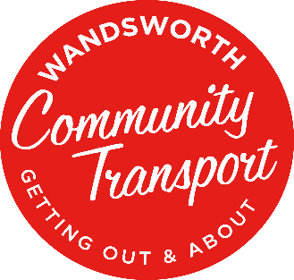
Wandsworth Community Transport
1b Yukon Road, SW12 9PZ - Registered Charity No. 286095

Trustee recruitment pack 2026
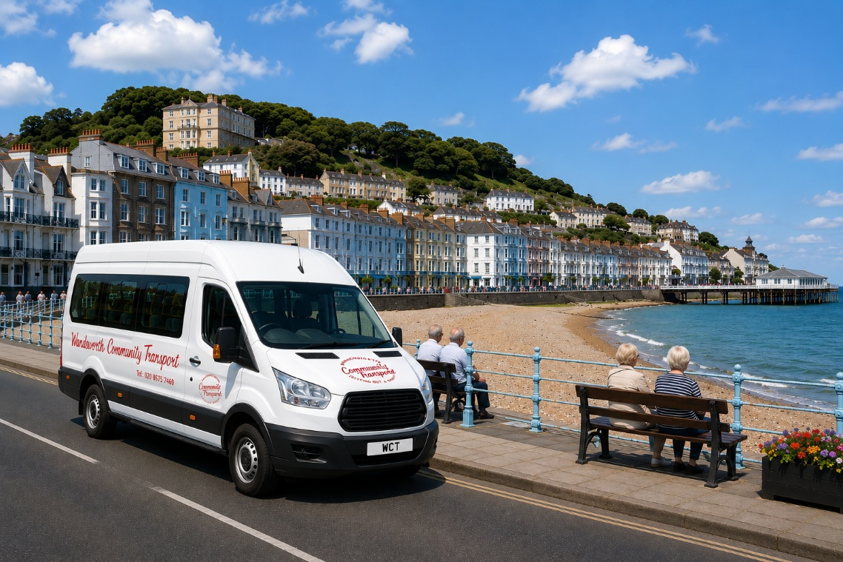

Contents
- Chair’s welcome
- About Wandsworth Community Transport
- Why join our Board now?
- Our Board
- What makes a great WCT Trustee?
- Trustee role profile
- Who we’re particularly looking for
- Meetings and time commitment
- Support and development
- Our commitment to DEIA
- How to apply

- Chair’s welcome
Thank you for considering becoming a Trustee of Wandsworth Community Transport.
WCT has been part of the community for more than 40 years. At the heart of what we do is something very simple: helping people to get where they need and want to go, and making it possible for people to remain independent, connected and involved in their community.
Our services are about much more than getting from A to B. They enable people to go shopping, enjoy days out, maintain friendships and social connections, and take part in everyday life. We also work with schools, charities and other community organisations across Wandsworth, helping them provide the transport their communities need.
It is a particularly exciting time to join us. Since our new Chief Executive joined WCT in May 2026, we are finalising our organisational strategy for the next three years – protecting the trusted services people already rely on while looking carefully at how WCT can become stronger, more sustainable and continue to respond to the changing needs of our community.
Our Trustees have an important part to play in that next chapter. We are looking to strengthen our Board with some particular skills and experience, but we are equally interested in the different perspectives people bring. You do not need to have been a Trustee before. We welcome people who share our commitment to inclusion, independence and community, who are curious about our work and who are willing to contribute their experience, ideas and time.
Being a Trustee is a responsibility, but it should also be rewarding and enjoyable. We are a friendly Board, working alongside a committed staff and volunteer team and an organisation with a long history of making a very practical difference to people’s lives.
I hope this pack gives you a sense of who we are, where we are going and what being part of WCT could look like. If what you read interests you, we would be delighted to hear from you.
Hicky Clark
Chair of the Board of Trustees
Wandsworth Community Transport
2. About Wandsworth Community Transport
Wandsworth Community Transport (WCT) has been helping people get out and about for more than 40 years.
Founded in 1982, we provide safe, accessible and affordable transport and opportunities for people to stay independent, connected and involved in community life across Wandsworth.
Today, our work includes:
- Shopmobility – Supporting people to access local shopping safely and independently, with transport and shopping support from our base at Sainsbury’s in Garratt Lane.
- Silver Day Trippers and Road Runners – Affordable outings giving people opportunities to visit new places, enjoy shared experiences and spend time with others.
- Community vehicle hire – Providing minibuses and transport to charities, community groups, sports clubs, places of worship and other local organisations.
- School and contracted transport – Delivering specialist transport, including work in partnership with the London Borough of Wandsworth and local schools.
- Driver training – Sharing our specialist knowledge through MiDAS training for drivers working within WCT and other organisations.
- WCT Community Transport Choir – Founded in May 2018 and made up of people who access our services alongside WCT volunteers. Our choir brings people together through music and performs at local events, day centres and community groups across Wandsworth.

Behind all of this is a committed team of staff, drivers, volunteers and Trustees, together with longstanding relationships across the borough.
Our work is about much more than transport. It is about enabling people to remain independent, build friendships, enjoy new experiences, play a role in their community and stay connected to the people and places that matter to them.
That sense of connection and participation is at the heart of WCT – and has been for more than four decades.
3. Why join our Board now?
WCT is entering an important and exciting new chapter.
Since Peter Edwards, our new Chief Executive, joined in May 2026 we have been finalising our organisational strategy for the next three years. Our focus is on protecting and strengthening the services our community already values, while building a resilient, sustainable and forward-looking organisation.
An important part of this will be diversifying our income and developing new collaborations and partnerships. We want to build on WCT’s strong local relationships, work more closely with other charities, community organisations, funders and businesses, and explore opportunities to work together where our combined experience can create greater impact.
Community participation and innovation will help shape WCT’s future. We want the people who access our services – alongside our volunteers, staff and wider community – to have a meaningful voice in what comes next. By listening, consulting and involving people from the earliest stages, we can understand changing needs, identify new opportunities and develop ideas with our community rather than simply for it.
Alongside protecting our core community transport services, we will actively encourage innovation – exploring new ideas, testing new approaches and learning from what works. This could mean using our transport expertise in new ways, developing new services, or working collaboratively with partners to respond to needs that no single organisation can address alone. Innovation at WCT will always be purposeful: rooted in evidence, shaped by participation and focused on creating greater impact for our community.
This makes it a particularly interesting time to become a Trustee.
New Trustees will be joining a well-established local charity, with strong community relationships, but at a point when there is also real opportunity to contribute to what comes next.
You will have the opportunity to bring your own knowledge, experience and perspective to our discussions, help shape our future direction and work alongside fellow Trustees, our Chief Executive and the wider WCT team as we take the organisation into its next chapter.
In 2027, WCT will celebrate its 45th anniversary – an important milestone for an organisation that has been part of local life since 1982. We want to enter that anniversary year proud of our history, open to new ideas, ambitious for our future and continuing to make a meaningful difference to the communities we are here to serve.
4. Our Board
Our Board of Trustees is responsible for the governance and strategic direction of Wandsworth Community Transport, working closely with our Chief Executive while maintaining the important distinction between governance and the day-to-day management of the charity.
Under the leadership of our experienced Chair, we are a friendly and engaged Board, bringing together a mix of professional expertise, community knowledge and lived experience. Our Trustees come from different backgrounds, and each brings something different to the table. We see that breadth of perspective as a real strength.
Trustees work collectively. No individual Trustee is expected to have all the answers. We ask questions, share knowledge, challenge constructively and support one another in making decisions in the best interests of WCT and the communities we serve.
Most matters are considered by the full Board, although we may establish smaller working groups for particular pieces of work when this is useful.
As WCT moves into its next chapter, we are also strengthening the way our Board works – including Board development, succession planning and more opportunities for Trustees to contribute to strategy.
Above all, we want our Board to be a place where different voices are heard and valued. We welcome challenge, curiosity and new ideas, and we want Trustees to feel able to contribute from their own experience while learning from others.
5. What makes a great WCT Trustee?
You do not need prior trustee experience to make a valuable contribution to the WCT board.
We are interested in people who care about our communities and believe in the importance of independence, inclusion and access to opportunities.
Great Trustees bring different things. You might bring professional expertise, knowledge of Wandsworth and its communities, insight from another sector, lived experience, or simply a perspective that is not currently represented around our Board table.
What matters to us is that you are willing to:
- Share knowledge, experience and ideas.
- Listen to and value different perspectives.
- Think strategically and look at the bigger picture.
- Ask questions and offer constructive challenge.
- Make decisions collectively and take shared responsibility for them.
- Champion inclusion, accessibility and community participation.
- Be curious, open to innovation and willing to learn.
- Act with integrity and always in the best interests of WCT and the communities we serve.

We particularly welcome people who can bring skills and experience to complement those already on our Board and we are committed to broadening the range of voices and perspectives involved in governance.
You will not be expected to arrive knowing everything about charity governance or community transport. We will support you to understand WCT, your responsibilities as a Trustee and the wider context in which we work.
What we are looking for most is people who want to contribute, participate and help us make good decisions together.
6. Trustee role profile
The role
As a Trustee of Wandsworth Community Transport, you will share responsibility with your fellow Trustees for the governance and strategic direction of the charity.
The Board works collectively to ensure that WCT remains true to its charitable purpose, is well governed and financially sustainable, manages its responsibilities and risks appropriately, and continues to deliver meaningful benefit for the people and communities we serve.
Our Chief Executive and staff team are responsible for the day-to-day running of WCT. The role of the Board is to provide strategic leadership, oversight, support and constructive challenge.
As a Trustee, you will:
- Help shape and oversee WCT’s strategic direction and future development
- Ensure that WCT remains focused on its charitable purpose and the needs of the communities it serves.
- Contribute actively to Board discussions and collective decision-making.
- Provide constructive support and challenge to the Chief Executive and senior team.
- Oversee WCT’s financial health and ensure its resources are used responsibly.
- Contribute to oversight of risk, safeguarding, legal and regulatory responsibilities.
- Support WCT’s commitment to diversity, equity, inclusion and accessibility.
- Champion meaningful community participation and ensure that the voices and experiences of the people we serve inform our thinking.
- Help WCT develop strong relationships, collaborations and partnerships.
- Act as an ambassador for WCT and help raise awareness of our work.
- Contribute your own knowledge, skills, networks and experience while respecting the perspectives of others.
- Act with integrity, confidentiality and in the best interests of WCT.

Collective responsibility
Trustees have collective responsibility for the decisions made by the Board. We therefore expect Trustees to prepare for and participate in meetings, contribute thoughtfully to discussions and support agreed decisions.
You will never be expected to manage WCT’s services or take on responsibilities that properly belong to our Chief Executive and staff team.
We want our Trustees to have the space to think strategically: asking the right questions, considering opportunities and risks, listening to our communities and helping WCT make well-informed decisions about its future.
Term of office
Trustees are appointed for a three-year term and may serve for a maximum of nine years, subject to reappointment and WCT’s governing arrangements.
The role is voluntary and unpaid, with reasonable expenses reimbursed in accordance with policy.
7. Who we’re particularly looking for
We want our Board to bring together a strong mix of skills, experience, backgrounds and perspectives.
Following our recent Board skills audit, we have identified some areas where additional experience would particularly strengthen WCT as we move into our next chapter.
You do not need to have previous Trustee experience, and we don’t expect any one person to cover all of these areas. We would particularly love to hear from people with experience in one or more of the following:
Fundraising + income generation
As we diversify our income and develop new partnerships, we would welcome someone with experience of fundraising, income generation or business development.
This might include trusts and foundations, corporate partnerships, individual giving, commissioning, strategic partnerships or other approaches to developing sustainable income.
We are particularly interested in someone who can bring strategic thinking – helping us identify opportunities, build relationships and strengthen our approach to income diversification rather than being expected to personally fundraise for WCT.
Legal + compliance
We would welcome someone with legal, regulatory, governance or compliance experience who can help strengthen the Board’s collective understanding and oversight in these areas.
You might be a practising or former legal professional, work in compliance or regulation, or bring relevant experience from the charity, public or private sector.
Diversity, equity, inclusion + accessibility (DEIA)
Inclusion and accessibility are central to the communities we serve and to the organisation we want WCT to be.
We would welcome someone who can bring knowledge, experience or perspective that helps us continue developing our approach to DEIA across our governance, services, workforce, partnerships and community engagement.
Marketing, communications + social media
We would love to strengthen the Board with someone who understands how good communications can help a charity connect with its community, tell its story and build relationships.
We are particularly interested in experience of marketing, communications, digital engagement or social media – helping us think strategically about how WCT communicates its impact, reaches different audiences and grows its profile across Wandsworth and beyond.
Lived experience + community perspective
Professional expertise is only one form of expertise.
We particularly value lived experience and would welcome people who can bring perspectives shaped by their own life, their communities or their understanding of the people WCT serves.
This might include experience of disability or accessibility barriers, caring responsibilities, ageing, social isolation, community services or community transport – whether personally, through your family or the wider community.
We also want our Board to better reflect the diversity of Wandsworth and encourage applications from people whose voices and perspectives have traditionally been underrepresented in charity governance.
8. Meetings and time commitment
We want prospective Trustees to have a clear and realistic idea of the commitment involved.
Our Board meets six times a year, in person, at 6pm in central Wandsworth. We also hold our AGM in November, which Trustees are expected to attend.
Trustees receive papers in advance of each Board meeting and are expected to take the time to read these and come prepared to contribute to discussion and decision-making.
Most of our governance work is undertaken through the full Board. From time to time, we may establish a small working group for a particular piece of work, drawing on the skills, experience and interests of individual Trustees.
As we develop our new three-year strategy, we also intend to create opportunities for Trustees to come together for strategic planning and Board development outside our regular meeting cycle.
We recognise that our Trustees have work, family and other commitments. We don’t expect everyone to be available for everything, but we do ask Trustees to participate regularly, stay engaged with WCT between meetings where needed and contribute their time and expertise in a way that is manageable and meaningful.
9. Support and development
We want every Trustee to feel welcomed, supported and confident in their role.
You don’t need to arrive knowing everything about WCT, community transport or charity governance. New Trustees will receive an induction to help you understand the organisation, our services, your responsibilities as a Trustee and how our Board works.
You will be supported by our experienced Chair, Chief Executive and fellow Trustees, with plenty of opportunity to ask questions and build your knowledge as you settle into the role.
We also encourage Trustees to get to know WCT beyond the Board table. This might include visiting our services, meeting staff and volunteers, joining one of our outings or community activities, and spending time with the people who access our services. We believe this first-hand understanding is an important part of being an effective WCT Trustee.
As a Board, we are committed to continuing to learn and develop. Trustees will have opportunities to take part in relevant training and Board development, as well as strategic planning sessions as we shape and oversee WCT’s future.
Whether this would be your first Trustee role or you already have considerable Board experience, we want you to feel able to contribute, ask questions, continue learning and enjoy being part of WCT.
10. Our commitment to DEIA
Diversity, equity, inclusion and accessibility are important to WCT – in the services we provide, the way we work and the way we govern our charity.
Our Board has adopted a DEIA Policy and Charter, alongside a three-year DEIA Strategy for 2026–2029 which will continue to develop as we learn, listen and strengthen our practice.
We want our Board to reflect a broad range of experiences, backgrounds and perspectives, and we particularly welcome applications from people in groups under-represented in charity governance.
We are committed to making our Trustee recruitment process as inclusive and accessible as possible. If there is anything we can do to make it easier for you to explore the opportunity, apply or participate in the recruitment process, please let us know.
For us, DEIA is not a finished piece of work. It is an ongoing commitment to listening, learning and ensuring that people have meaningful opportunities to participate in and help shape WCT.
11. How to apply
Thank you for considering joining the Board of Wandsworth Community Transport. We hope this pack has given you a sense of who we are, what matters to us and why this is such an exciting time to become part of WCT.
If you are interested in joining us, there are two ways to take the next step.
Arrange an informal conversation
If you would like to find out a little more before deciding whether to apply, Peter Edwards, our Chief Executive, would be very happy to have an informal conversation with you about WCT, the Trustee role and any questions you may have; an opportunity to find out more and decide whether WCT feels right for you.
Contact Peter Edwards, Chief Executive:
Email: peter.edwards@wctbus.org.uk
Tel.: 020 8675 7460
Or complete your application now
If you have read this pack and already feel that you would like to apply, you are very welcome to complete your application now by completing the form provided with this pack.
We want to understand what interests you about WCT and what you feel you could bring to our Board. We are interested in your experience, skills and perspective – whether these have come through your professional life, volunteering, your community or your lived experience.
We recruit Trustees on a rolling basis, although we may set closing dates when recruiting for particular skills or experience.
What happens next?
Following your application, we will invite shortlisted applicants to meet with us. This is an opportunity for us to learn more about you, but equally for you to learn more about WCT and decide whether joining our Board feels right for you.
We look forward to hearing from you.

