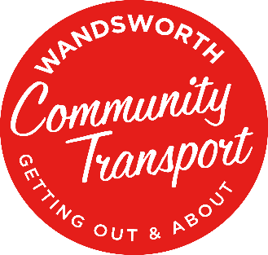

Monitoring Form

Respect for diversity and difference is important to Wandsworth Community Transport, and we aim to make working with us accessible to all.

Our funders require us to collect monitoring data to ensure that we are providing an inclusive service.

All data collected is kept confidential and you can help us by completing this form and returning it with your application please.

You

Male ☐ | Female ☐ | Other ☐ | Prefer not to say ☐

Age

Under 18 ☐ | 18-25 ☐ | 26-40 ☐ | 41-55 ☐
55-64 ☐ | 65 and over ☐ | Prefer to not say ☐

Are you?

Employed ☐ | Unemployed ☐ | Retired ☐
Student ☐ | Other ☐

Do you identify as a member of the LGBTQ+ community?

Yes ☐ | No ☐ | Prefer to not say ☐ | Prefer to self-describe ☐

Do have a religious affiliation?

Yes ☐ | No ☐ | Prefer to not say ☐ | Prefer to self-describe ☐

Do you have a disability?

Yes ☐ | No ☐ | Prefer to not say ☐
If yes, please give any details you would like to share about how we can support you:

What is your ethnic group?

Choose ONE section from A to E and then tick the appropriate box, to indicate your cultural background:

A: White | B: Mixed | C: Asian or Asian British | D: Black or Black British | E: Any other identification
British ☐ | White and Black Caribbean ☐ | Indian ☐ | Caribbean ☐
Irish ☐ | White and Black African ☐ | Pakistani ☐ | African ☐
 |  | Bangladeshi ☐
Any other White background | Any other mixed background | Any other Asian background | Any other Black background | Prefer not to say  ☐

Thank you for completing this form.

